Parts
SCAT Hose Part No: 01046 (600mm)
Per side:
Pushrod Part No: A-003466 Long Right (291mm)
A-001491 Long Left (305mm)
Firewall boot, Part No 42-G20.04.
Fitting ring, Part No 42-G20.05.
Six blind rivets Ø 3,2x7.5 mm (clamping range= 3,1-4,3mm) NiCu/St Part No 01072
Pattex transparent contact adhesive Part No 9999X

Disassembly
Remove lower cowling.
Remove SCAT hose if damaged, or cut cable ties and secure to one side if not.

If firewall boot is damaged:
The boot is secured to the firewall by the fitting ring. Drill out the rivets securing the fitting ring to the firewall (loosen the backing material in the footwell for access).
Remove the old boot and fitting ring.

If pushrod is damaged:
Release the ball joints at each end of the pushrod and remove it.

Reassembly
Cut the ends of the firewall boot as shown to allow it to splay out where the fitting ring will secure it.
Arrange the boot to point slightly downwards as shown.
Glue the new firewall boot to the fitting ring with “Pattex Kraftkleber” transparent contact adhesive to make fitting easier.

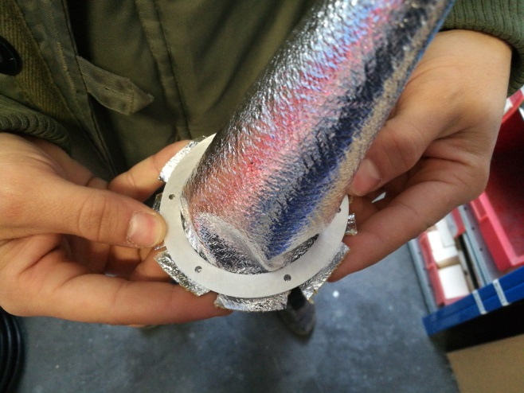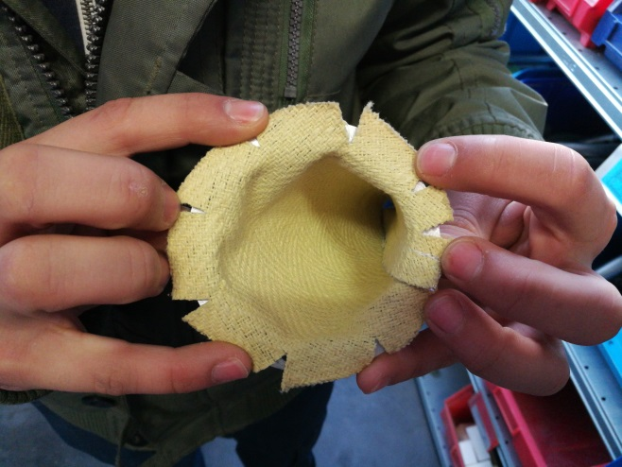
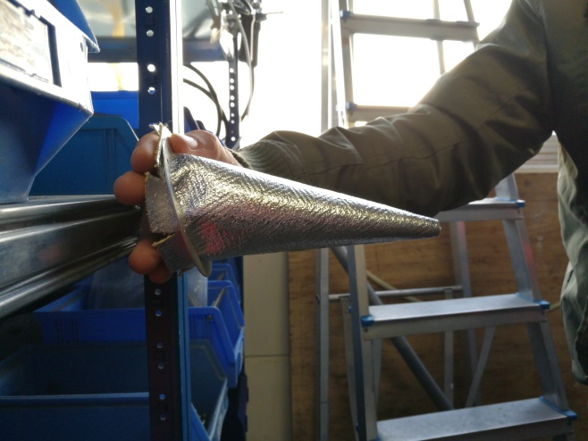

Rivet the boot to the firewall, installing the rivets from the engine side of the firewall.

Slide the pushrod into place and secure the end clips.
Replace the SCAT hose if required. Secure it with tie-wraps in a position where it does not cause further damage. It may be necessary to slightly shorten the SCAT hose to allow it to take up a better position clear of the pushrods.
Refit the lower engine cowling.

